Galaxy database
(MySQL installation on RHEL 5.4)

1 Introduction 2
1.1 Minimum hardware configuration 2
1.2 Recommended Hardware Configuration 2
1.3 MySQL installation web page 2
2 MySQL 5.1 installation on RHEL 3
2.1 MySQL Download 3
2.2 MySQL 5.1 Installation 4
2.3 Verifications 12

Introduction

Minimum hardware configuration

For acceptable performances, the Galaxy server holding and managing the MySql database should at least be the following:

Computer type | PC
OS | Windows XP
Processor speed | 2 GHertz
RAM | 1 Gb
Hard disk | 100 Gb

Recommended Hardware Configuration

We recommend the following configuration for the Galaxy server holding and managing the MySql database:

Computer type | PC
OS | Windows XP
Processor speed | 3 GHertz single-core OR  2 GHertz dual-core
RAM | 4 Gb
Hard disk | 250 Gb

MySQL installation web page

The following page explains in details the standard MySQL 5.1 installation on RHEL:
http://dev.mysql.com/doc/refman/5.1/en/linux-installation-rpm.html

MySQL 5.1 installation on RHEL

MySQL Download

Download the latest official MySQL 5.1 release at:
http://dev.mysql.com/downloads/mysql/5.1.html#downloads

In the ‘Select Platform’ combo box, select Red Hat & Oracle Enterprise Linux

The CPU value indicates the processor type or family for which the package is built.

MySQL Installation Packages for Linux CPU Identifier
CPU Value | Intended Processor Type or Family
i386 | x86 processor, 386 and up
x86_64 | 64-bit x86 processor
ia64 | Itanium (IA-64) processor

Download the Server and Client packages corresponding to your system configuration, ie. if the CPU value is i386:

Red Hat & Oracle Enterprise Linux 5 (x86, 32-bit),
RPM Package 5.1.52 20.4M Download
MySQL Server
(MySQL-server-community-5.1.52-1.rhel5.i386.rpm) MD5: e49afe4e533371daf6e98a105dbd6721

Red Hat & Oracle Enterprise Linux 5 (x86, 32-bit),
RPM Package 5.1.52 20.4M Download
Client Utilities
(MySQL-client-community-5.1.52-1.rhel5.i386.rpm) MD5: 825a9ce948b17d2f9070bc9cb58e7751

Notes:

- the release may be a more recent one than the one displayed on this document. Simply download the latest available release.
- prior to the download, you will be asked to create a MySQL account. Although this is a good practice, you may skip it by clicking the “» No thanks, just take me to the downloads!” link.

MySQL 5.1 Installation

During RPM installation, a user named mysql and a group named mysql are created on the system. This is done using the useradd, groupadd, and usermod commands. Those commands require appropriate administrative privileges, which is ensured for locally managed users and groups (as listed in the /etc/passwd and /etc/group files) by the RPM installation process being run by root.

The screenshots provided in below procedures (in the boxes) are examples. The instructions they contain may eventually need to be adapted to your system environment. The results shown may also vary depending on your system environment.

- Login as root
- Cd to the directory where you downloaded the RPM packages
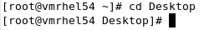
- Install Mysql-server
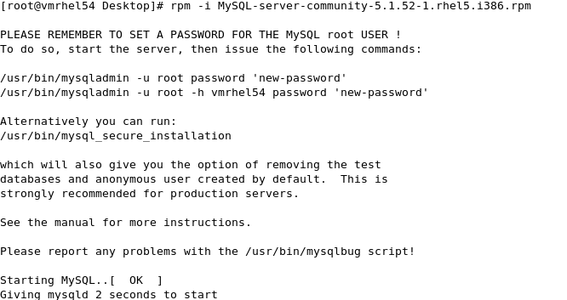
- Install Mysql-client
- Run the secure installation script
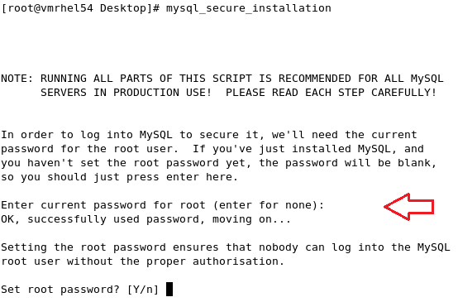
Note: When asked for the current root password, just hit ‘Enter’, as it is blank on initial installation.
Set the root password:
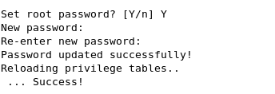
Remove anonymous user:
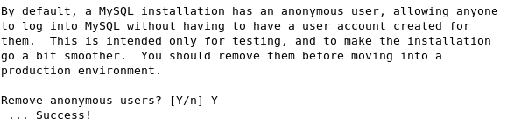
Leave remote login allowed:
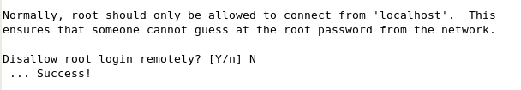
Remove test database:
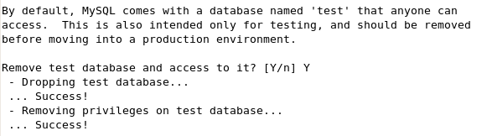
Reload privilege tables:
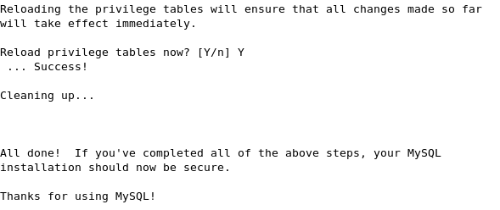
- Allow remote MySQL root login
When creating schema and users for the GEXDB database, Yield-Man needs to connect to MySQL using the MySQL root user. To allow doing this from a remote system, we have to instruct MySQL to allow the MySQL root user to connect from remote systems.
Log to MySQL as root:
Enter MySQL root password:
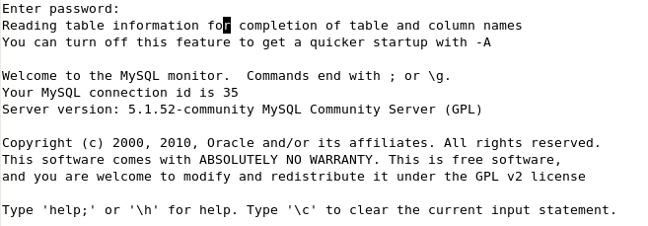
Update root attributes:
Exit:
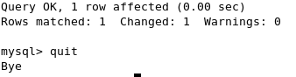
- MySQL parameters tuning
Some MySQL parameters have to be set for a good integration with the Yield-Man solution. This section will also cover the optional move of the MySQL data directory, which is the directory where MySQL stores all data files. By default, this directory is /var/lib/mysql. You might want to change it if you have more space available elsewhere on your disk(s).
Stop the MySQL server:
Prepare the new data directory (skip this section if the default directory is Ok):
  - In the following screen-shot instructions, replace “/bigspace/mysql_data” with the directory you want MySQL to store the data in.
  - Create the new directory (if need be):
  - Make sure your new directory has the correct permissions:
  - Copy files from old to new data directory:
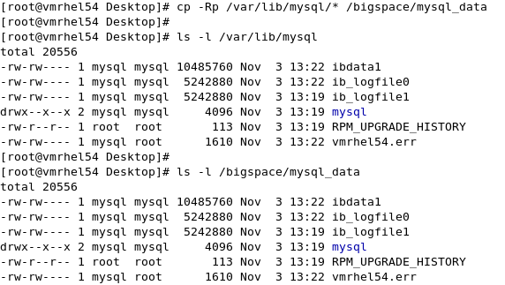
  - Remove duplicate files/folders:
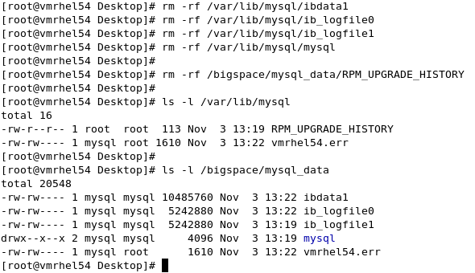
  - Modify SELinux parameters (check “Boolean->Disable SELinux protection for mysqld daemon”):
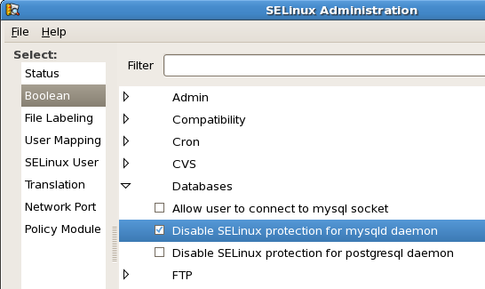
Create/edit /etc/my.cnf file:
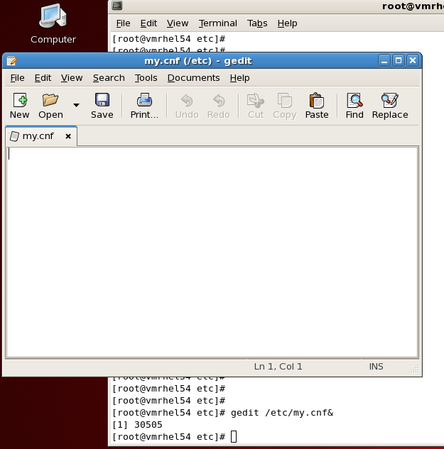
Add following required lines:
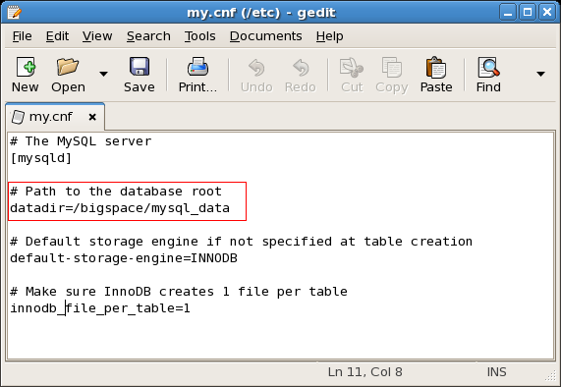
Note: add the “datadir” line outlined in red only if you moved the MySQL data directory in above section.
Start Mysql server:

The installation of the MySQL server is now completed!

Verifications

Make sure 3306 port is opened for client connections:
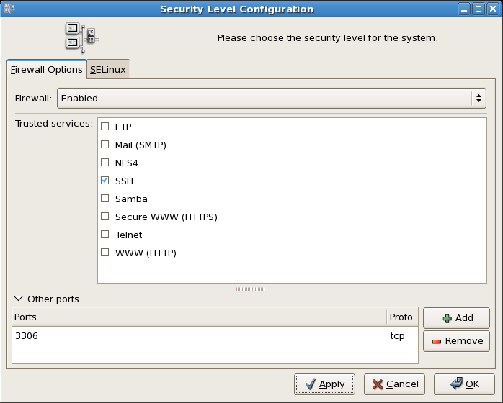

Make sure mysqld is running:

